West Hull Ladies
RRC

January Newsletter

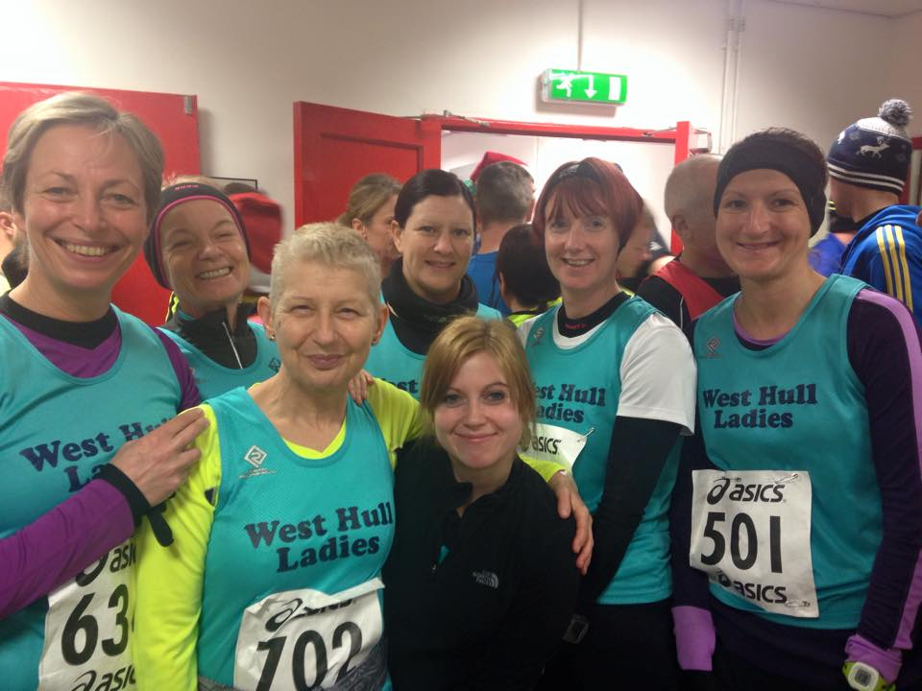
Boxing Day 10k

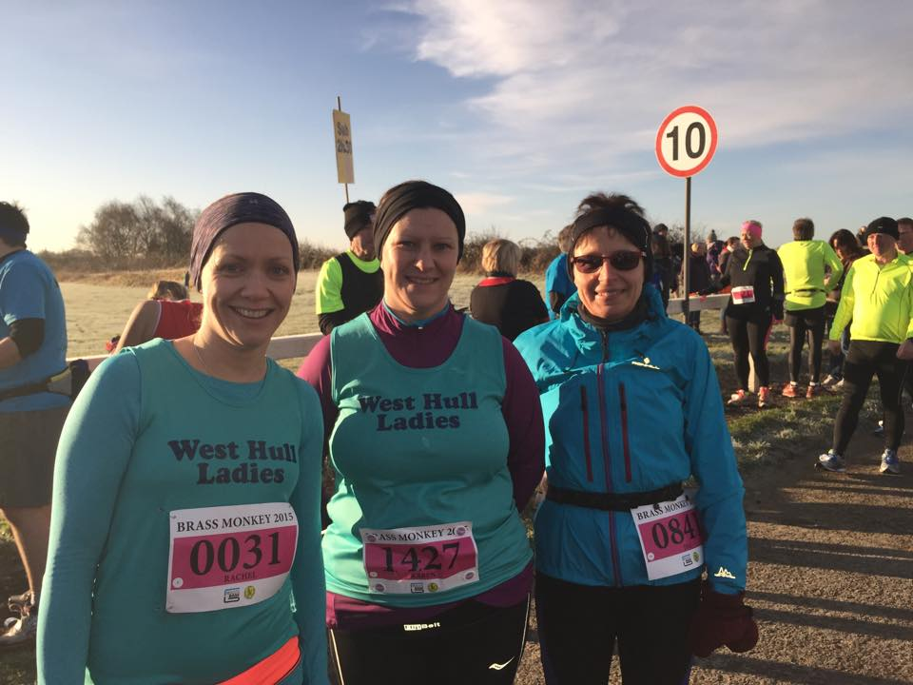
Brass Monkey ½ Marathon 18th January

West Hull Ladies

WEST HULL LADIES RRC COMMITTEE MEETING

Committee Meeting
Minutes 5th January 2015

Present, Sandra, Amanda, Maria, Linda

- Apologies from Annette, Verity, Karen, Jill, Rachael and Hayley.
- Minutes from previous meeting accepted as true record
- Matters arising. Kit dealt with under agenda item 11, Amanda not yet had chance to document the administration of the 0-5k course but once she has she hopes to get more help for 2016 if we run it again and Rachael had booked the Back Room at Cottingham for presentation evening 27th March 2015.
- Amanda updated the committee about the 0-5k course. Tonight had been the first day and 9 people had attended. Following Linda’s feature on Radio Humberside more people were joining the course and it is believed now full. Amanda asked that gait analysis be arranged for week 3 of the course preferably on a Tuesday/Thursday. Action Rachael to organise with Humber Runner.
- Amanda would not be organising the Christmas Advent Calendar run this year. The committee thanked her for all she had done and felt sure that nearer the time one or more ladies would take on this task. It was too early for people to commit for an event in December. Please see footnote at end of minutes
- The AGM that was to be separate from the presentation evening would take place on Monday 2nd March 2015. All members invited.
- Membership fees would stay as they are despite the increase to £12 for membership of UK Athletics. Fees for those aged 16-18 would be £15 per year as opposed to £30 for those over 18 years. Action Amanda to update web site.

- Linda and Amanda to prepare audited accounts to present to members at the AGM. Action Linda and Amanda to meet and prepare.
- The committee thanked Rachael for booking the venue. Awards discussed and it was felt that as Jill had completed this last year she be asked to use the same criteria system for this year. Action Jill to sort out awards and to ask for help from committee if needed.
- Golden Fleece discussed. This is a 16 or 27-mile walk/run organised by local scouts. Several members had completed this last year. Recces had already been completed and further ones were in hand.
- Sandra had been in touch with exercise direct who could get us navy hoodies at a price of £7.50 plus VAT. They were unable to mark them up with ‘West Hull Ladies” or provide teal running vests. Maria was to order new vests from our current providers. Action Sandra to cost embroidery for hoodies.
- Heidi Bradley from England athletics had arranged for 2 workshops to take place at the YPI - these are free to West Hull Ladies but places have to be booked by either ringing Heidi and leaving all details on 07968 498701 or emailing all details to hbradley@englandathletics.org. The workshops are 1. Monday 23rd Feb between 7-9pm Foam Rolling and 2. Monday 9th March between 7-9pm and covers injury prevention.
Action Sandra to put out email to members
Advent Calendar Organising
I would like to step down from organising the advent calendar run next year. It's not a massive job to be done but just another of the things I am doing and I need to do less. It's also a very positive event.
Organising can be split into:
- Organising the run (the Avenues magazine lists the windows)
- Book room, advertise (send words to add to the emails), collect up numbers (Annette or I can forward emails to the organiser)
- Food and drink (more than one person?)
- Entertainment - this year it is my laptop with WHL 2014 photos and Christmas music.
Hoping for a volunteer,
Amanda

BOXING DAY 10K - LINDA

The lovely Jan and her brother, Pete, picked me up this morning to take us to East Hull for the Boxing Day 10k. Thank you Jan for the lift, very much appreciated.

When we arrived and registered we were joined by Sara, Sally, Barbara, Karen, Jane and Suzanne. There seemed lots of runners milling around so a very popular race. Their clubhouse is lovely and warm so we stayed inside as long as possible before making our way to the start. It was a cold morning and had even started raining a little (I hate rain)!

Finally the whistle went off and we were away, I could still feel my Christmas dinner so maybe I shouldn’t have had my morning porridge at 7am! (note for next year no eating on Boxing Day morning)!

Sara, Sally and myself stayed together until we got onto the old railway track then Sara shot off in front leaving Sally and I behind, now where did that extra burst of energy come from? Although we could see her up front there was no way we could have caught her unless someone set fire to our running tights! Sally and I continued to run together until we reached the housing estate, I knew we didn’t have to long to go so I settled into my pace and gritted my teeth and soldiered on. Sally stayed just behind me. I could see Jan’s brother, Pete, in front, he is so tall you couldn’t really miss him! I was aiming to catch him up, he’d never ran a 10k race before and I think 5k was all he’d ever done. I did catch him and overtook him, that made me smile! So now I was approaching ‘that hill’ which I hated when I ran the East Hull 20! I could see Sara was at the top of it so I remembered our hill training and motored to the top and there was a lovely surprise at the top, Ann had come on her super bike thingy to cheer us on, what a lovely smile she had and it gave me the extra boost I needed to get me to the finish.

Finally after a lovely downhill run the finish was in sight so I sprinted the final few metres. Sara was at the finish waiting for us and just behind me was Sally. We waited until all the other ladies came in encouraging them to the finish line. Then it was home to a lovely hot shower. I’m so glad I did this race, it was fun. Oh and we got lots of support from the lovely chaps from City of Hull, I enjoyed the hug they gave me!

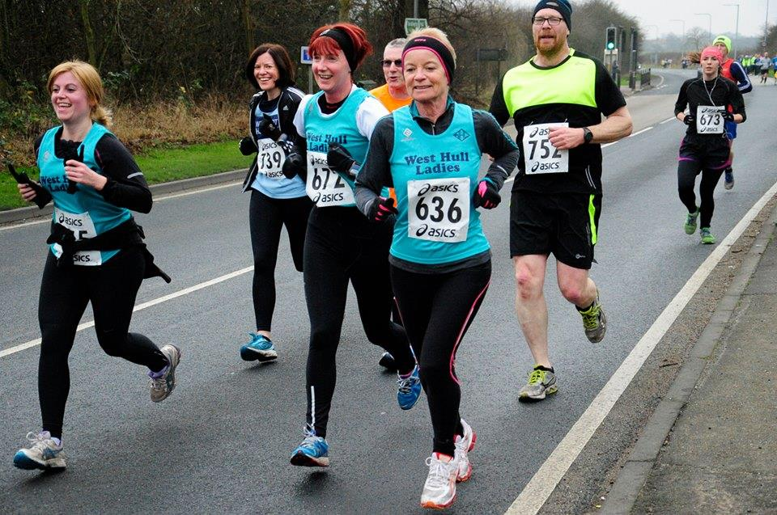

BRASS MONKEY - JILL
Good Results for WHL.

Unfortunately Jane was poorly and very sensibly decided to stay in bed and rest. Me, Rachel and Karen, took the plunge to run the Brass Monkey half on a very very cold and icy day (minus 2)!

This is a nice flat course that runs from York racecourse south into the vale of York. Just a couple of road bridges, which are a bit of a pain at around the 12 mile mark...ouch! I think we all did really well, given that we had black ice for about 2 miles between miles 4-6 making it very very slippery, which was really difficult to negotiate. Both Rachel and myself got lifetime PB's so we were really chuffed. Karen ran really well given that she has only just got better from a chest infection, and has missed quite a lot of training. I started off with too many clothes on, as usual, and generally stripped off as I went along the course. Spoke to some really nice people on the way, particularly discussing the ice under foot! I chatted to a nice guy who originally came from Hull for a bit of the way, also a couple of women who were marathon training, so we were all being really careful on the ice. I passed a guy who had overtaken me in the first couple of miles, when I was trying to chase going under 2 hours, in the last mile, who encouraged me on, and Richie from city of Hull gave me a big cheer up the finish line. I was a bit gutted that I missed going under 2 hours by 16 seconds, but was pleased with a PB by over 2 minutes :) Generally speaking this was a well organised event, with nice marshals who were cheering us all on. The XS long sleeved tee shirt was a good fit instead of being like rent a tent. Great company, a nice course, a tee shirt that fits, and an excuse to eat a snickers bar as recovery 'food'...what more can anyone want (lol!)... so all in all a good day.

Rachel Anderson 1.52:35
Jill Jameson 2.00:16
Karen Scott 2.24:43

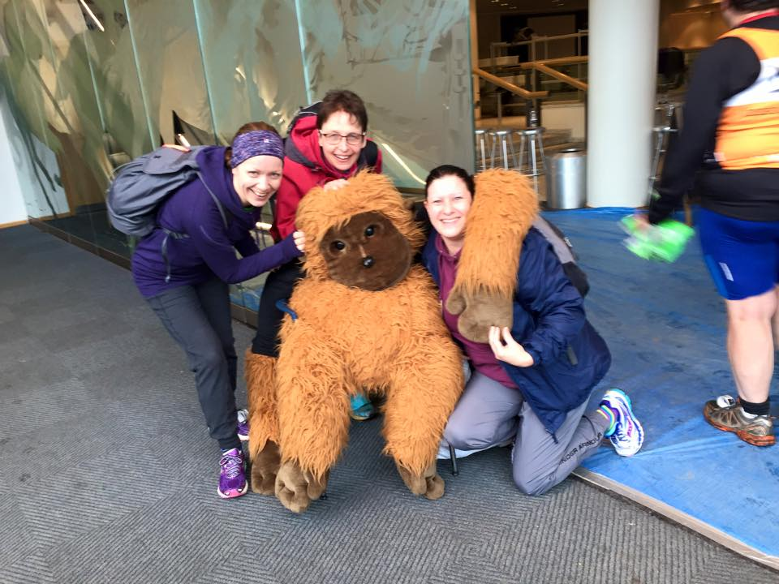

SHIN SPLINTS - SANDRA

Shin splints (the term for pain that occurs on the front outside part of the lower leg) often occurs when your legs are overworked. That's sometimes from a jump in mileage. And sometimes because your shins pick up the slack for body parts that are weak, says Susan Joy, M.D., a sports and exercise medicine physician. Protect yourself by strengthening your feet, ankles, calves, and hips, which support your shins. Do two to three sets of 10 to 15 reps daily (but not before a run):
Toe Curls
Stand with feet hip-width apart at the edge of a towel. With the toes of your left foot, gather the towel and slowly pull it toward you. Return to start and repeat with the other foot.

Monster Walks
With feet shoulder-width apart, place a resistance band around your thighs and step forward and toward the right with your right leg. Bring your left leg up to meet your right, then step out toward the left. Then walk backward in the same way to return to the start. Repeat.

Heel Drop
Stand on your toes on the edge of a step. Shift your weight to your right leg, take your left foot off the step, and lower your right heel down. Return to start, and then repeat with your left leg.

One-Legged Bridges
Lie on your back with your arms out to the sides, knees bent, and feet flat on the floor. Squeeze your glutes to lift your hips up off the floor. Extend your left leg out and hold for 30 seconds (work up to 60-second holds), then lower it. Repeat with your other leg.

Here are some tips that will help alleviate your shin pain:

Massage with Ice
Freeze a paper cup filled with water, tear off the top edge of the cup, and massage with comfortable pressure along the inside of the shinbone for 10 to 15 minutes after running to reduce inflammation.

Add Arch Support
By "lifting" the arch with insoles, you take stress off of your lower legs. You don't need to use these forever if you do strength work–think of insoles like a splint for your foot and remove them once you're fully recovered. Try different options available at running shops.

Stretch & Rest
Loosen up tight calves and Achilles tendons–both can contribute to shin splints. Reduce running mileage and do low-impact cross-training (biking, swimming, elliptical) instead. When you resume your training, ease in gradually. Too much too soon could cause a relapse.

HAPPY SOUNDS! - ANNA

What to listen to when running?

When I first started to run again after a children sized gap- part of the motivation was that I would be able to listen to my own music- uninterrupted. No nursery rhymes or themes to cartoons, and no demands for juice/ toilet/ toys etc. It was also a sort of flash back to a past when I used to love going out and having a good dance. Music and moving- running's not so different to clubbing really!

I have experimented with different styles of music. Sometimes I feel like reminiscing. Old tunes are really distracting- lots of nice memories to think about instead of thinking about how far there is still to do. Some tunes however are disappointing- old gothy rock from my youth is just not the right beat for my speed of running. Cheesy dance music is my reliable motivating choice for most runs- bright, happy and just the right beat, although over summer I listened to a lot of my husbands old early rave which was perfect for long miles in lots of sunshine. Great for daydreaming to.

Once when I had a new phone that I didn't understand enough to be able to put music onto, I ended up listening to the radio. It surprised me how enjoyable it was for running to. I thought that it would be too stop start, but people chatting away was really comforting and good company. I probably did look a bit foolish giggling along to DJ stories and getting cross at the news, but I don't care about that one bit! I enjoy the radio for a long run that could get lonely.

Of course, in a race, no headphones are allowed. Running in silence worried me on my first race. However, I really enjoyed feeling part of the environment instead of being in my own little bubble- especially in a race in a particularly special or pretty landscape. I am also more aware of other runners, even meeting some of them- park run is a good music-free run for this.

But the best sound of all to run to is of course the natter of West Hull Ladies! Our club manage to turn exercise and training into a sociable event. Chatting away is distracting and also a great form of therapy! Happy sounds!

RECIPES

Anna’s Apple cake
I had a request for the recipe of an apple cake that we had post run, which I'm afraid that I make up as I go along- a basic sponge recipe, with chopped apples in it at the end. However, this is a more specific recipe which is exactly the same:

450g cooking apples (such as Bramley)
juice of ½ lemon
225g butter, softened
280g golden caster sugar
4 eggs
2 tsp vanilla extract
350g self-raising flour

2 tsp baking powder
Demerara sugar, to sprinkle if you like

- Heat oven to 180C/fan 160C/gas 4 and butter and line a baking tin with parchment paper. (makes a tray bake)
- Peel, core and thinly slice (or cut into chunks- that fine) the apples then squeeze the lemon juice over. Set to one side.
- Place the butter, caster sugar, eggs, vanilla, flour and baking powder into a large bowl and mix well until smooth.
- Spread half the mixture into the prepared tin. Arrange half the apples over the top of the mixture, then top with the rest of the mixture..
- Sprinkle over the demerara sugar.
- Bake for 45-50 mins until golden and springy to the touch.
- Leave to cool for 10 mins, then turn out of tin and remove paper. Cut into bars or squares.
I'm afraid that I cannot justify this recipe as anything more than a treat after a run- sorry! You will have earned it though!

****************************************************

Keralan Fish Curry – Hayley

For those curry lovers out there – this is so easy and quick to make and really tastes like you have slaved over the cooker for hours making it, not to mention full of healthy fats and spices!

1 tbs coconut oil
1 tsp mustard seeds
1 onion thinly sliced
2 cloves garlic, peeled & crushed
2cm root ginger, peeled & grated
1 red chilli, finely sliced
1 1/2tsp ground coriander
1 tsp fenugreek
1 tsp turmeric
16-20 curry leaves
600ml coconut milk
700g firm fish – I use frozen salmon, tuna, cod fillets
200g king prawns

Warm the oil in large wide pan. Add the mustard seeds and let them pop in the heat, try not to lose too many! Add the onions & garlic & cook for 7-8 mins until soft.

Add the chilli, ginger, ground coriander, fenugreek & turmeric. Cook with the onion for 2-3 mins. Pour in the coconut milk and add the curry leaves. Season with salt and simmer for 8-10 mins.
Cut the fish into large chunks. Submerge in the sauce along with the prawns and cook gently for 5-6 mins until cooked through. The curry sauce is meant to be thin but is packed with flavour!

I serve with boiled/pilau rice cooked with a cinnamon stick for extra flavour.

2015 RACE DIARY

Free 5K time trial every Saturday 9am: Hull Parkrun or Peter Pan Parkrun

Fancy something different? For worldwide marathons click here

January 2015
25th/10:00 | Ferriby 10 Mile
February 2015
8th/10:00 | British Heart Foundation Harewood House Half Marathon
22nd 10:30 | Snake Lane 10 Mile
March 2015
7th/08:30 | Golden Fleece 15 mile and 27 mile
 | East Hull 20 Mile

Please remember to double check dates, times and entry fees Keep checking the website for new races and updates:

NOTE: Club Vests must be worn at any races you enter
under the West Hull Ladies running club name

Golden Fleece Recce – 18th Jan from North Cave (13 miles)

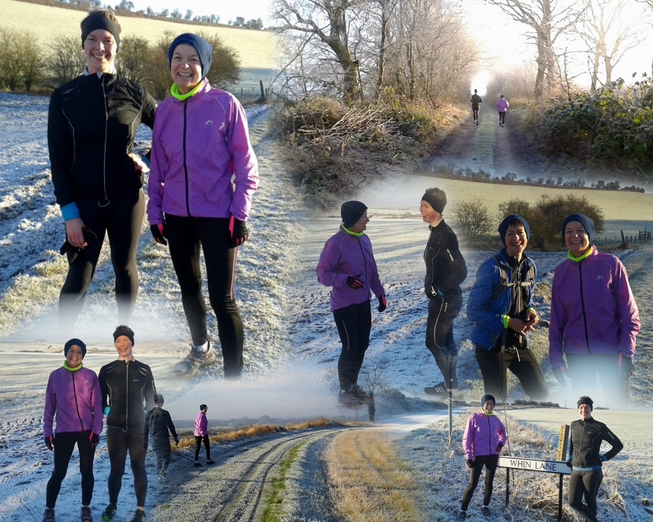

Liz, Linda & Amanda
Perfect day for an off-road run.

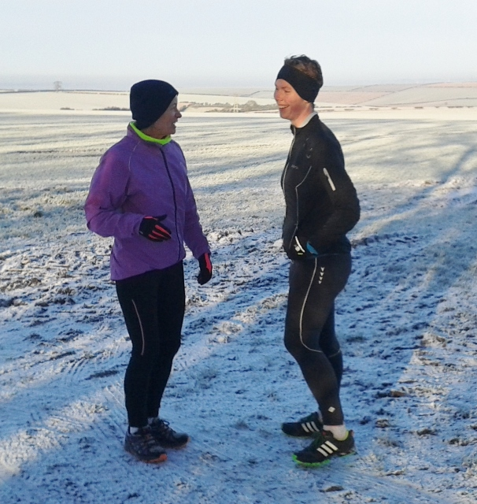

West Hull Ladies Road Running Club
Kit Order Form

FORENAME ___________________________________

SURNAME ___________________________________

ORDER - tick what you require, with size Price
- VEST SIZE _____________ £16.00
- LONG SLEEVED SIZE _____________ £18.50
- BEANIE HAT £6.50

DATE Ordered _______________

AMOUNT PAID _______________

Please transfer payments online with your name and marked as ‘Kit to:
Account: 63762742 Sort Code: 20 43 49.
Or cheque payable to ‘West Hull Ladies RRC’, and write your name and ‘Kit’ on the back and give to Club Treasurer Linda Dodsworth, 110 The Stray, South Cave HU15 2AL
Sign on receipt of goods _________________________________
DATE _______________

Please complete this form and email to diazmaria@btinternet.com
Thanks.
Maria Kit Officer

